Moorestown Tennis Club Summer Camp 2024
June 24th-August 23rd
Half Day Camp 9-12pm|1-4pm Full Day Camp 9-4pm
$350/week $80/day $475 week $110/day
Offering 9 weeks
-Rookie Camp Ages 5-10 9-12pm
This Camp will focus on Rally Development, Footwork, Fitness, Sportsmanship, Stroke Development and of course Fun. Kids in this camp will enjoy many activities that improve their overall athletic progress and tennis skills. Red, Orange, and Green Ball progressions used.
-Player Development Camp Ages 11-18 9-12pm 
This Camp will allow beginner and intermediate players to building technique, fitness, match play ability and more!
-Advanced Training Camp Ages 10-18 9-12pm 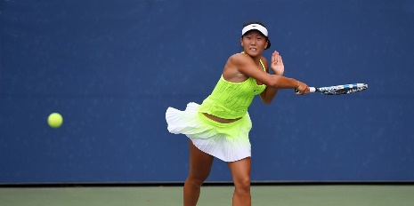
This program will work on Challenging Drills, Conditioning, Mechanics, Video Analysis and Matchplay Production.
Designed for competitive tournament player development.

-Matchplay Training Camp/Open Play Ages 10-18 1-4pm (Players must have basic serve and rally skills)
(Green Ball and higher may participate in this camp)
This Afternoon program will allow participants to improve their match play while working on tactics, scoring, and competition skills. Coach Analysis. For full day campers, we offer fun open play format. Basketball, Pickleball, Badminton, are some of the activities for kids to balance out the day along with their tennis training. Players can choose to play tennis matches or select any other sports activity for the afternoon.
Early Registration Discount!!!! 10% off before June 1st
*Registrations for Summer Camp are non-refundable*

Moorestown Tennis Club
HIGH SCHOOL PREP CAMP SUMMER 2024
Week 1: July 22nd-July 26th|Week 2: July 29th-August 2nd
9-4pm

-Camp Overview-
Stretching and warm-up exercises
Doubles Strategy and Opponent Type Recognition
Singles Tactics
Competitive Matchplay
Serve and Return of Serve Production

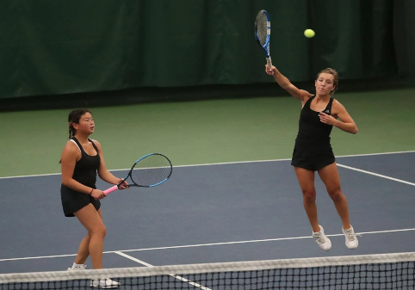
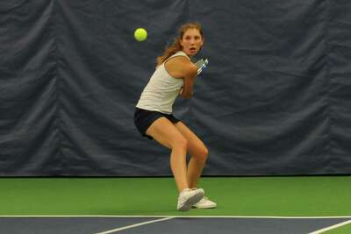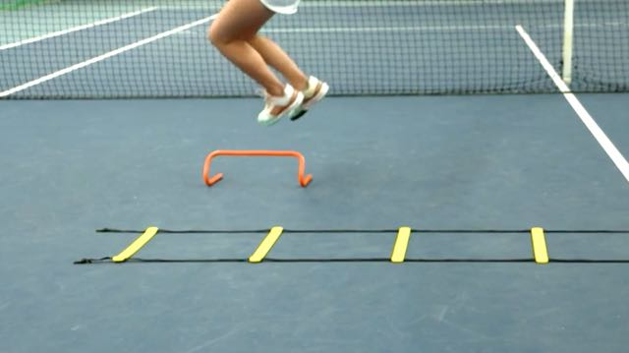
$450/week $100/day

*Sign up before June 1st and get 10% off*

SUMMER CALENDAR OVERVIEW OF EVENTS
Moorestown Tennis Club 2024
CAMP SCHEDULE
Week 1: 6/24-6/28 | Half Day and Full Day Camp
Week 2: 7/1-7/5 | Half Day and Full Day Camp *July 4th Half Day Only
Week 3: 7/8-7/12 | Half Day and Full Day Camp
Week 4: 7/15-7/19 | Half Day and Full Day Camp
Week 5: 7/22-7/25 | Half Day and Full Day Camp/HS Training
Week 6: 7/29-8/2 | Half Day and Full Day Camp/HS Training
Week 7: 8/5-8/9 | Half Day and Full Day Camp
Week 8: 8/12-8/16 | Half Day and Full Day Camp
Week 9: 8/19-8/23 | Half Day and Full Day Camp

Junior Program Schedule

12 & Under Clinics (Red, Orange, Green Ball)
June 24th-August 14th
Wednesdays 6-7pm 8 weeks $200/package $30/Drop In

